Explainable CNN-Based Brain Tumor Detection in MRI Using Edge-Enhanced Input and Grad-CAM Attention Localization
Muhammad Abdullah Zaka, Ali Husnain Saqib
Department of Computer Science, COMSATS University Islamabad, Wah Campus, Pakistan

Abstract—Early detection of brain tumors in magnetic resonance imaging (MRI) supports timely treatment, but manual reading is slow and varies between readers. Convolutional neural networks (CNNs) can automate detection, yet they return a bare probability that gives clinicians no evidence to trust, and raw scans often show low contrast along lesion boundaries. Many classification datasets also lack tumor masks, so annotation-free localization is needed. We propose an explainable pipeline that blends Canny edge maps with the input MRI (70% original, 30% edges) before classification by a VGG16 network fine-tuned from ImageNet. Grad-CAM and a lightweight region-of-interest (ROI) extraction step then show where the model focuses and report the area and bounding box of the highlighted region. On the Kaggle Brain MRI Images for Brain Tumor Detection dataset (253 images), the pipeline reaches 96.84% accuracy and 97.42% precision, recall, and F1-score in a full-dataset batch evaluation. Grad-CAM attention is focal on tumor scans and diffuse on a healthy control scan. The result is a transparent, lightweight baseline for computer-assisted neuro-oncology research on small datasets. The ROI output shows model attention and is not a validated tumor boundary. Code: [insert GitHub link].
Keywords—brain tumor detection, convolutional neural networks, Grad-CAM, explainable AI, Canny edge enhancement, transfer learning, MRI analysis

1. INTRODUCTION
Brain tumors are a heterogeneous group of central nervous system neoplasms whose prognosis and treatment depend on tumor type, size, and location [1]. Magnetic resonance imaging (MRI) is the primary non-invasive modality for assessing them, and accurate interpretation directly affects diagnosis and surgical planning. Reading MRI is demanding, however. A radiologist must inspect many slices per patient, small or low-contrast lesions are easily missed, and manual delineation of the same tumor differs appreciably between expert raters [2].
Deep learning, and convolutional neural networks (CNNs) in particular, now dominate automated medical image analysis [3], including brain tumor classification and segmentation [4]. Medical datasets are small, which makes training from scratch unreliable. Transfer learning addresses this by reusing networks such as VGG16 [5] pretrained on ImageNet. Fine-tuning such networks can match or exceed training from scratch in medical imaging when labeled data are limited [6], because early layers learn generic edge and texture filters that transfer across domains [7].
Accuracy alone, however, is not enough for clinical use. A CNN returns a bare probability, such as “99.5% tumor,” with no indication of the evidence behind it. This matters because models can learn spurious cues. A study of chest radiograph classifiers found that a network partly relied on site-specific signals unrelated to disease [8]. Gradient-weighted Class Activation Mapping (Grad-CAM) [9] partly addresses this by highlighting the regions that most influenced a prediction. Saliency maps still need careful interpretation, since some methods fail sanity checks [10] and do not by themselves make a model clinically reliable [11].
Two gaps remain for lightweight pipelines. First, raw MRI often has low contrast along tissue transitions, which limits the structural cues reaching the early convolutional layers. Classical operators such as the Canny edge detector [12] expose these boundaries, but they do not generalize like deep features. Second, pixel-level localization usually needs encoder-decoder networks such as U-Net [13] and nnU-Net [14], which require pixel-wise tumor masks. Many classification datasets, including the one used here [15], contain no masks. A practical pipeline therefore needs annotation-free localization whose limits are stated honestly.
In this paper, we ask whether combining classical edge enhancement with transfer learning and Grad-CAM gives a compact, transparent detector on a small MRI dataset. Each scan is edge-enhanced and classified by a fine-tuned VGG16. Grad-CAM and an ROI extraction step then show where the model attended and quantify that region (Fig. 1). Our contributions are:
- An edge-enhanced preprocessing scheme that blends Canny edges with the original MRI (70%/30%) so the network receives both texture and boundary information.
- An explainable detection and localization pipeline that pairs a partially fine-tuned VGG16 with Grad-CAM heatmaps and an ROI step reporting area and bounding box, framed explicitly as model attention rather than tumor boundary.
- An evaluation on 253 MRI images, giving 96.84% accuracy and 97.42% precision, recall, and F1-score, with a negative-control analysis and a dashboard for automated reporting.
The rest of the paper is organized as follows. Section 2 reviews related work, Section 3 describes the method, Section 4 reports experiments and discussion, and Section 5 concludes with limitations and future work.
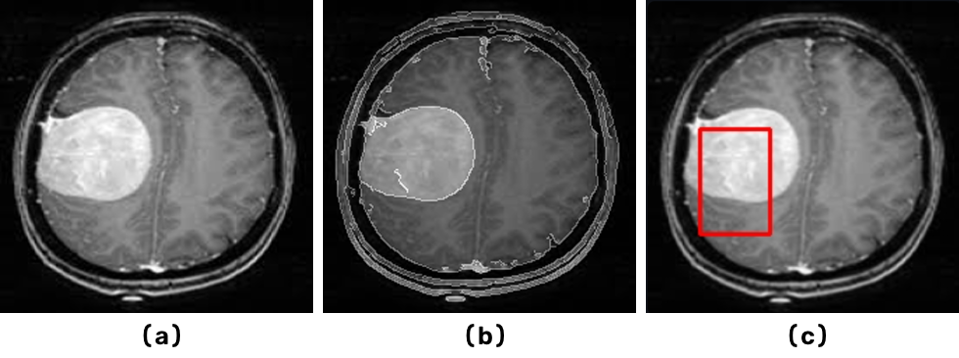
Fig. 1. Teaser. (a) Input MRI. (b) Edge-enhanced input. (c) Suspected ROI box derived from Grad-CAM attention.

REFERENCES

[1] | A. P. P. W. D. J. B. I. A. C. D. F.-B. e. a. D. N. Louis, "The 2021 WHO classification of tumors of the central nervous system: a summary," Neuro-Oncology, vol. 23 / 8, p. 1231–1251, 2021.
[2] | A. J. S. B. e. a. B. H. Menze, "The multimodal brain tumor image segmentation benchmark (BRATS)," IEEE Transactions on Medical Imaging, vol. 34/10, p. 1993–2024, 2015.
[3] | T. K. B. E. B. A. A. A. S. F. C. M. G. e. a. G. Litjens, "A survey on deep learning in medical image analysis," Medical Image Analysis, vol. 42, p. 60–88, 2017.
[4] | A. P. V. A. C. A. S. S. Pereira, "Brain tumor segmentation using convolutional neural networks in MRI images," IEEE Transactions on Medical Imaging, vol. 35 / 5, p. 1240–1251, 2016.
[5] | A. Z. K. Simonyan, "Very deep convolutional networks for large-scale image recognition," in Proc. ICLR, 2015.
[6] | J. Y. S. S. R. G. R. T. H. C. B. K. M. B. G. J. L. N. Tajbakhsh, "Convolutional neural networks for medical image analysis: full training or fine tuning?," IEEE Transactions on Medical Imaging, vol. 35/5, p. 1299–1312, 2016.
[7] | J. C. Y. B. H. L. J. Yosinski, "How transferable are features in deep neural networks?," in Proc. NeurIPS (Advances in Neural Information Processing Systems), 2014.
[8] | M. A. B. M. L. A. B. C. J. J. T. E. K. O. J. R. Zech, "Variable generalization performance of a deep learning model to detect pneumonia in chest radiographs," PLOS Medicine, vol. 15 / 11, p. e1002683, 2018 .
[9] | M. C. A. D. R. V. D. P. D. B. R. R. Selvaraju, "Grad-CAM: visual explanations from deep networks via gradient-based localization," in Proc. ICCV, 2017 .
[10] | J. G. M. M. I. G. M. H. B. K. J. Adebayo, "Sanity checks for saliency maps," in Proc. NeurIPS, 2018 .
[11] | L. O.-R. A. L. B. M. Ghassemi, "The false hope of current approaches to explainable artificial intelligence in health care," The Lancet Digital Health, vol. 3 / 11, p. e745–e750, 2021.
[12] | J. Canny, "A computational approach to edge detection," IEEE Transactions on Pattern Analysis and Machine Intelligence, vol. 679–698, pp. PAMI-8 / 6, 1986.
[13] | P. F. T. B. O. Ronneberger, "U-Net: convolutional networks for biomedical image segmentation," in Proc. MICCAI, 2015 .
[14] | P. F. J. S. A. A. K. J. P. K. H. M.-H. F. Isensee, "nnU-Net: a self-configuring method for deep learning-based biomedical image segmentation," Nature Methods, vol. 18 / 2, p. 203–211, 2021.
[15] | N. Chakrabarty, "Kaggle," Brain MRI images for brain tumor detection, 2019. [Online]. Available: https://www.kaggle.com/datasets/navoneelchakrabarty/brain-mri-images-for-brain-tumor-detection.

